Data Structures



Submitted to
Mr. Bilal Bukhari

Submitted by
Hasnat Gul
FA25-BCS-030

COMSATS UNIVERSITY ISLAMABAD
(ATTOCK CAMPUS)

LAB TASK 01:
CODE:
#include <iostream> using namespace std;

int main()
{
int x, start, stop; int sum = 0;

cout << "Enter value of X: "; cin >> x;

cout << "Enter starting value: "; cin >> start;

cout << "Enter stopping value: "; cin >> stop;

for (int i = start; i <= stop; i++)
{
sum = sum + (x * x);
}

cout << "Sum = " << sum;

return 0;
}
Output:
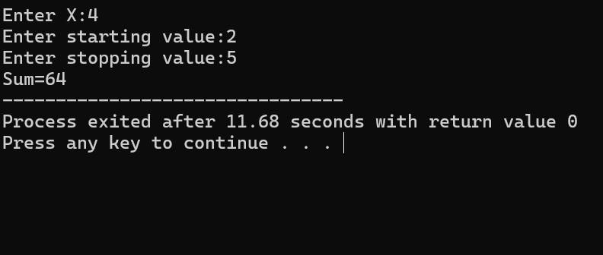
Lab task 02:
Code:
#include <iostream> using namespace std;

class ArrayList
{
private:
int arr[100]; int size;

public:

ArrayList()
{
size = 0;
}

// 1. Insert at end void insertEnd(int val)
{
if (size < 100)
{
arr[size] = val; size++;

cout << "Inserted " << val << " at end\n";
}
else
{
cout << "List full!\n";
}
}

// 2. Insert at start void insertStart(int val)
{
if (size < 100)
{
for (int i = size; i > 0; i--)
{
arr[i] = arr[i - 1];
}

arr[0] = val; size++;

cout << "Inserted " << val << " at start\n";
}
else
{
cout << "List full!\n";
}
}

// 3. Insert after specific value void insertAfter(int after, int val)
{
int pos = -1;

for (int i = 0; i < size; i++)
{
if (arr[i] == after)
{ pos = i; break;
}
}

if (pos == -1)
{
cout << after << " not found!\n"; return;
}

if (size < 100)
{
for (int i = size; i > pos + 1; i--)
{
arr[i] = arr[i - 1];
}

arr[pos + 1] = val; size++;

cout << "Inserted " << val << " after " << after << endl;
}
else
{
cout << "List full!\n";
}
}

// 4. Insert before specific value void insertBefore(int before, int val)
{
int pos = -1;

for (int i = 0; i < size; i++)
{
if (arr[i] == before)
{ pos = i; break;
}
}

if (pos == -1)
{
cout << before << " not found!\n";
return;
}

if (size < 100)
{
for (int i = size; i > pos; i--)
{
arr[i] = arr[i - 1];
}

arr[pos] = val; size++;

cout << "Inserted " << val << " before "
<< before << endl;
}
else
{
cout << "List full!\n";
}
}

// 5. Display void display()
{
if (size == 0)
{
cout << "List is empty!\n"; return;
}

cout << "List: ";

for (int i = 0; i < size; i++)
{
cout << arr[i] << " ";
}

cout << endl;
}

// 6. Delete from end void deleteEnd()
{
if (size == 0)
{
cout << "List empty!\n"; return;
}

cout << "Deleted " << arr[size - 1]
<< " from end\n";

size--;
}

// 7. Delete from start void deleteStart()
{
if (size == 0)
{
cout << "List empty!\n";
return;
}

cout << "Deleted " << arr[0]
<< " from start\n";

for (int i = 0; i < size - 1; i++)
{
arr[i] = arr[i + 1];
}

size--;
}

// 8. Delete specific value void deleteVal(int val)
{
int pos = -1;

for (int i = 0; i < size; i++)
{
if (arr[i] == val)
{ pos = i; break;
}
}

if (pos == -1)
{
cout << val << " not found!\n"; return;
}

for (int i = pos; i < size - 1; i++)
{
arr[i] = arr[i + 1];
}

size--;

cout << "Deleted " << val << endl;
}
};

int main()
{
ArrayList list;

int choice, val, target;

do
{
cout << "\n===== MENU =====" << endl; cout << "1. Insert at end" << endl; cout << "2. Insert at start" << endl; cout << "3. Insert after specific value" << endl; cout << "4. Insert before specific value" << endl; cout << "5. Display list" << endl; cout << "6. Delete from end" << endl; cout << "7. Delete from start" << endl; cout << "8. Delete specific value" << endl; cout << "9. Exit" << endl;

cout << "Choice: "; cin >> choice;

switch (choice)
{
case 1: cout << "Enter value: "; cin >> val;

list.insertEnd(val); break;

case 2:
cout << "Enter value: "; cin >> val;

list.insertStart(val); break;

case 3:
cout << "Enter after value: "; cin >> target;

cout << "Enter new value: "; cin >> val;

list.insertAfter(target, val); break;

case 4: cout << "Enter before value: "; cin >> target;

cout << "Enter new value: "; cin >> val;

list.insertBefore(target, val); break;

case 5: list.display(); break;

case 6: list.deleteEnd(); break;

case 7: list.deleteStart(); break;

case 8: cout << "Enter value to delete: "; cin >> val;

list.deleteVal(val); break;

case 9: cout << "Exiting...\n"; break;

default: cout << "Invalid choice!\n";
}

} while (choice != 9);

return 0;
}
Output:
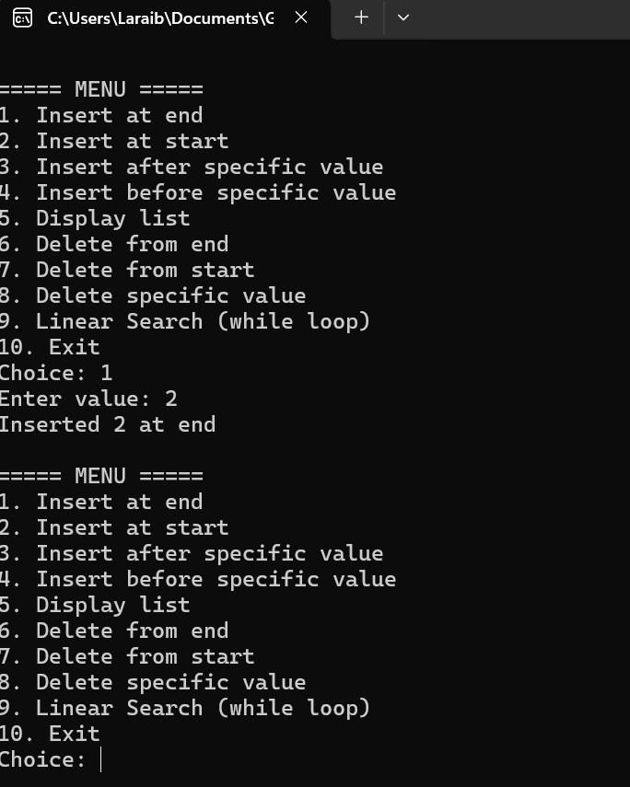
Lab task 03:
Code:
#include <iostream> using namespace std;

int main()
{
int arr[100], size, search, i;

cout << "Enter number of elements: "; cin >> size;

cout << "Enter " << size << " elements: ";

for (i = 0; i < size; i++) cin >> arr[i];

cout << "Enter value to search: "; cin >> search;

i = 0;

while (i < size && arr[i] != search)
i++;

if (i < size)
cout << search << " found at index " << i << endl; else
cout << search << " not found!" << endl;

return 0;
}
Output:
